Name : Lesego Malepe

St. No : 10459533

Module : Introduction to Web Development

Task : Ice Task 1

****

Contents

[Business Background 3](#_Toc193191913)

[Marketing Related Thinking Behind Website 3](#_Toc193191914)

[Unique Selling Proposition: 3](#_Toc193191915)

[Brand Identity & Messaging 3](#_Toc193191916)

[Motivation for Developing the Website 3](#_Toc193191917)

[Objectives of Having a website 4](#_Toc193191918)

[List of Resources 4](#_Toc193191919)

[User Persona 4](#_Toc193191920)

[Sitemap 5](#_Toc193191921)

# Business Background

Established: April 2024

Location: 4532 Ext 8 Far East Bank, Alexandra. Johannesburg.

Type of Business: Manufacturing & Retail

Product/Services: Liquid Soaps, e.g, Dishwashing Liquid.

# Marketing Related Thinking Behind Website

Audience: Households & Businesses

## Unique Selling Proposition:

1. Locally Sourced Ingredients – We use South African-sourced ingredients like aloe vera, caustic soda and pine oil to create a proudly South African product.

2. Affordable & Student Friendly – A high-quality yet budget-friendly option for students and young professionals.

# Brand Identity & Messaging

Handcrafted with South African ingredients to bring you the best in natural cleaning ingredients

A high-quality, affordable liquid soap made for students, businesses and families.

Our soap is handcrafted with care, making it more premium and special than mass-produced alternatives in terms of quality control.

# Motivation for Developing the Website

Building a Digital Identity: Establishing an online presence to showcase the brand’s unique values and commitment to quality.

Streamlining Customer Experience: Allowing customers to easily browse and purchase products in one place.

Educating Consumers: Providing insights on the benefits of natural and locally sourced ingredients in liquid soap.

# Objectives of Having a website

Direct to Customer Sales: Eliminating the need for middlemen by offering products directly to customers.

Business Growth and Scalability: Positioning the brand for future expansion by reaching a wider market beyond local sales.

# List of Resources

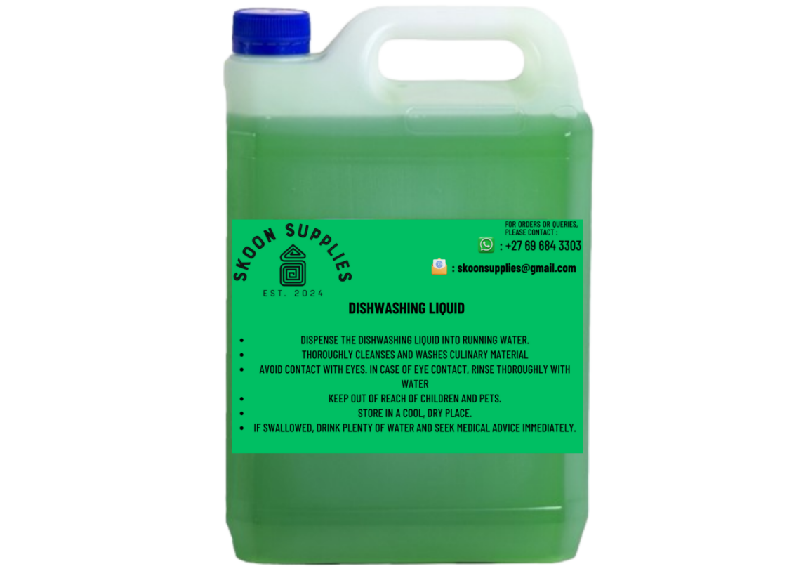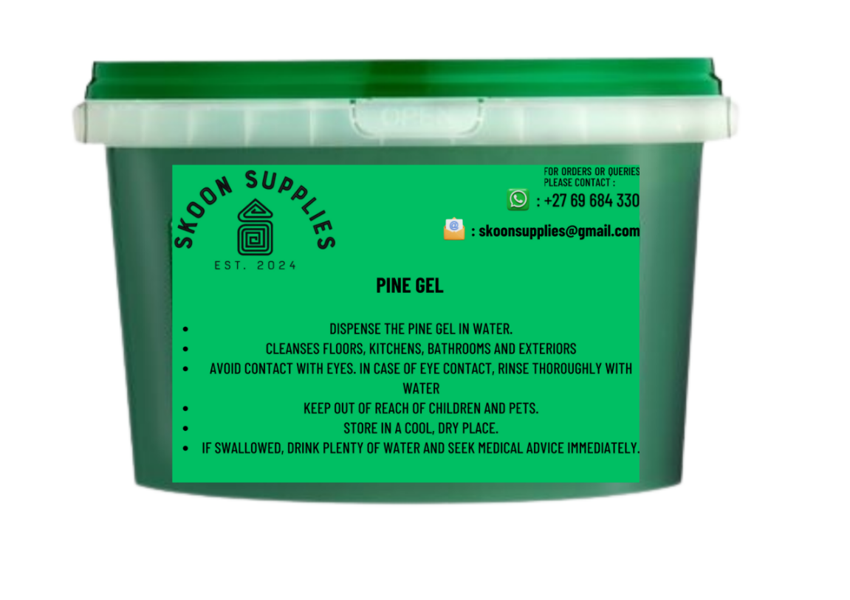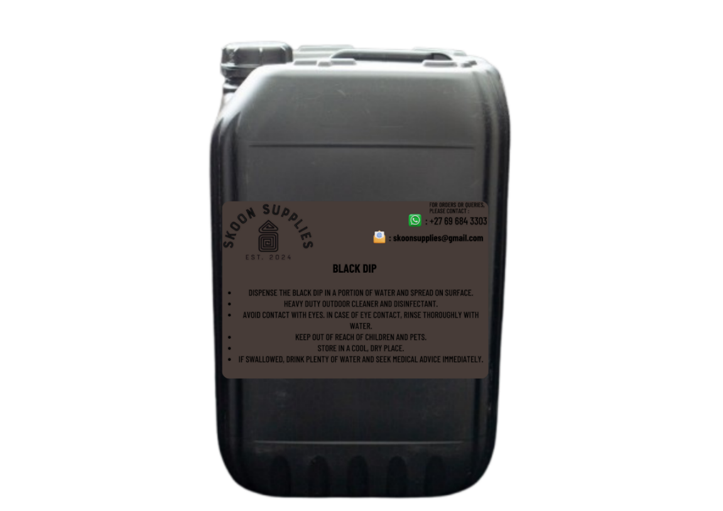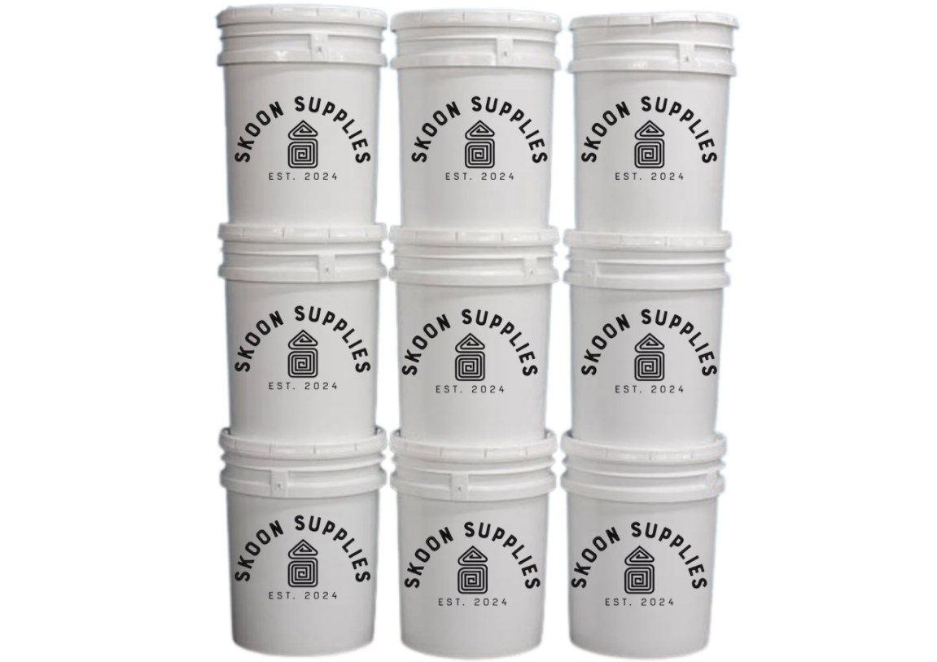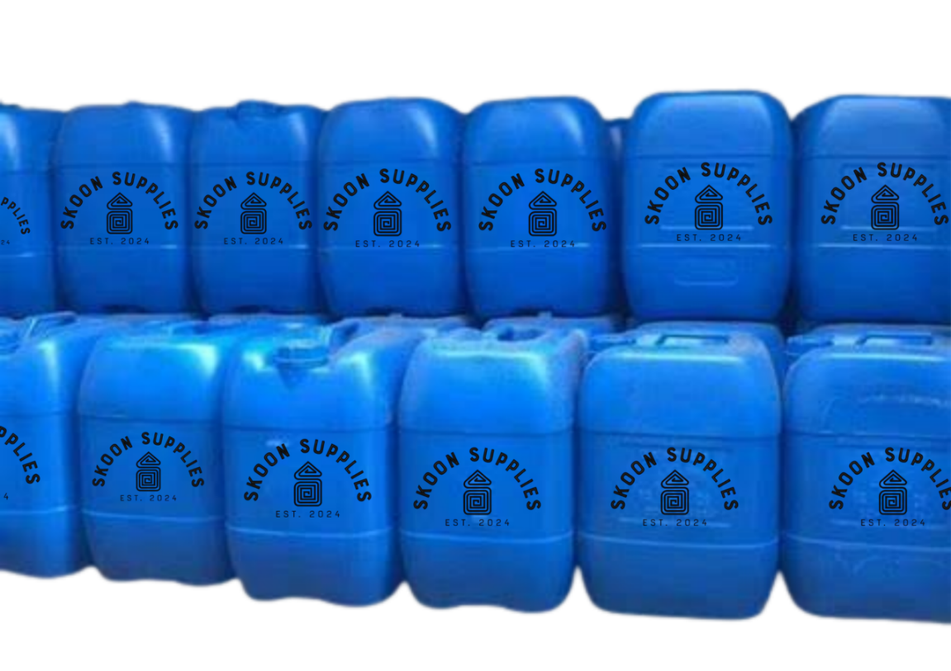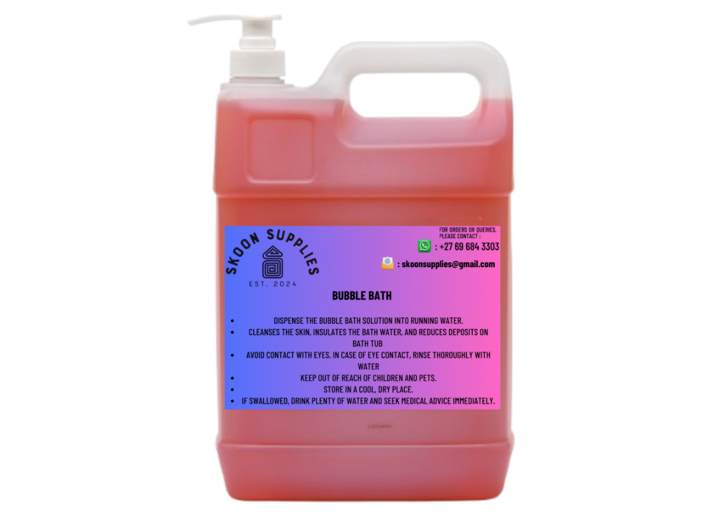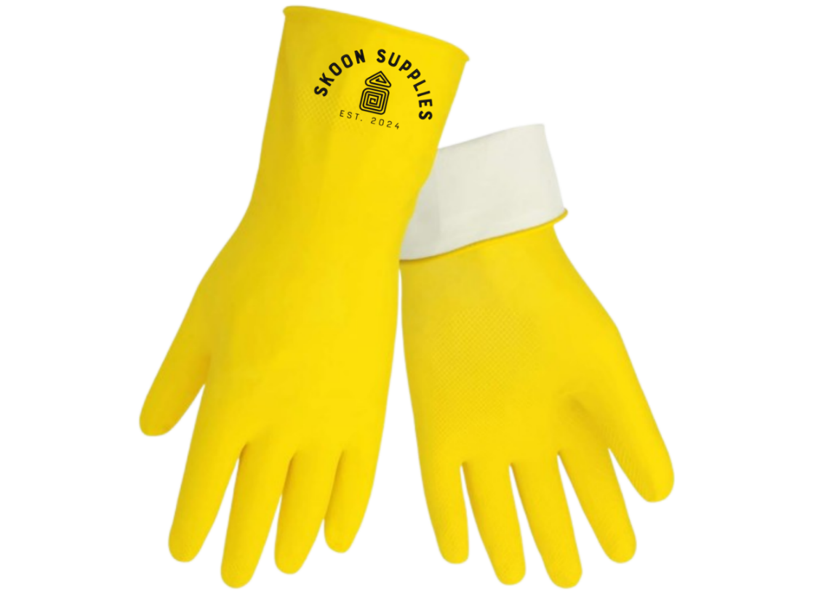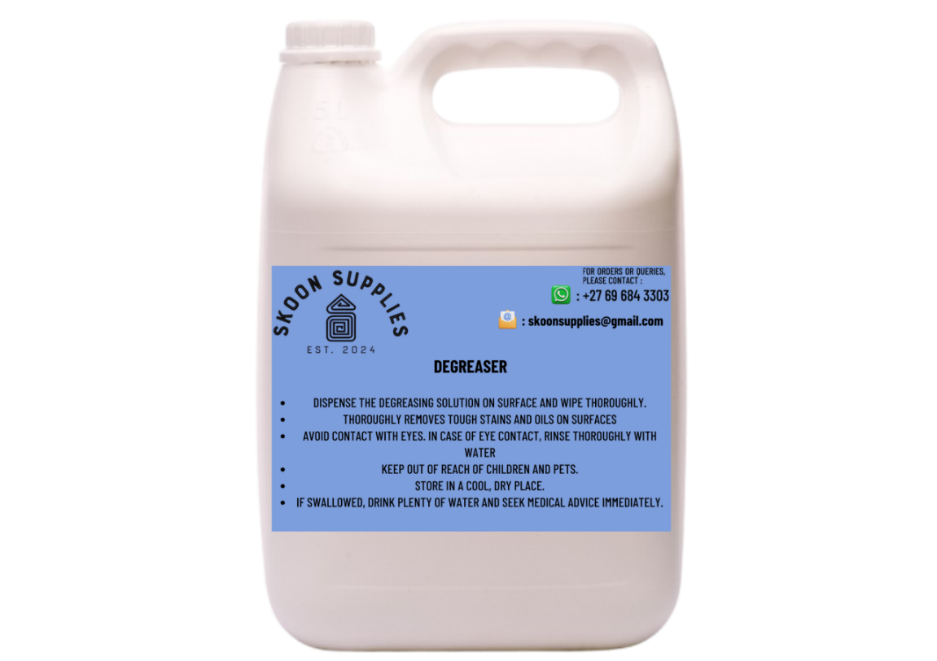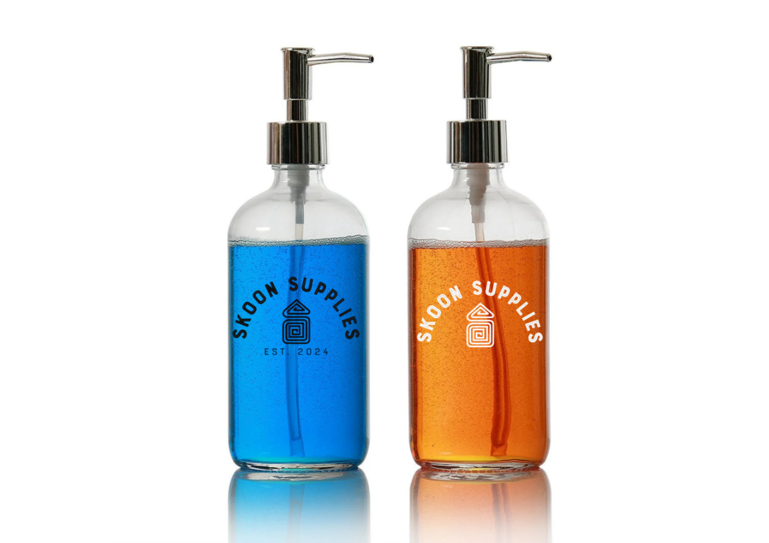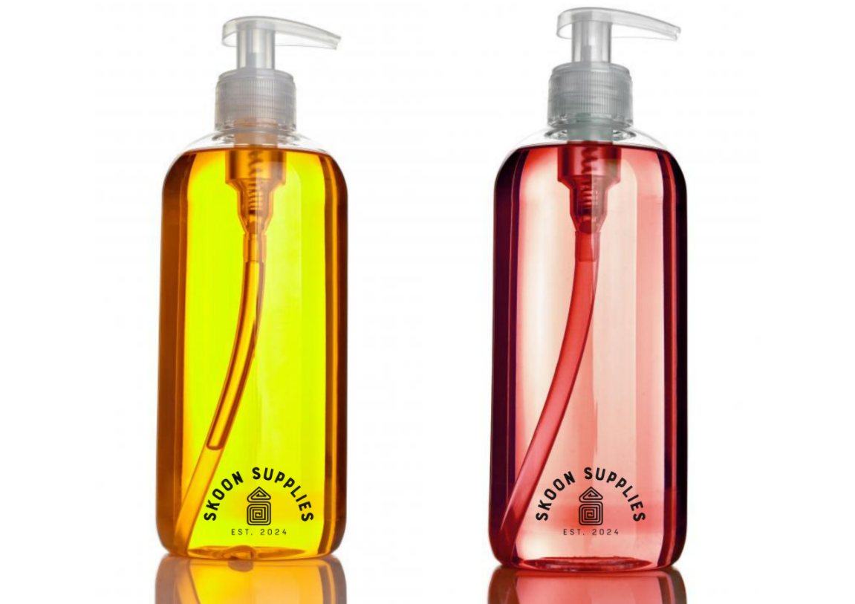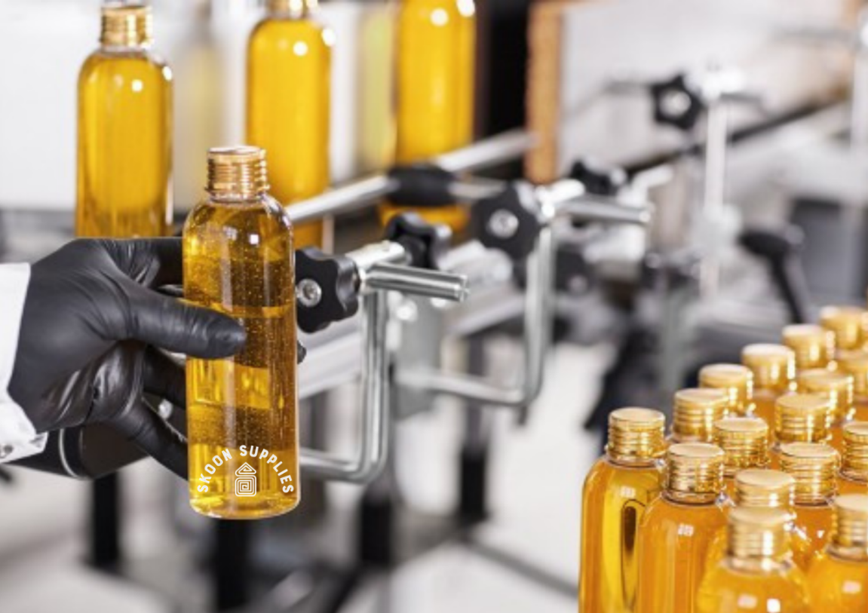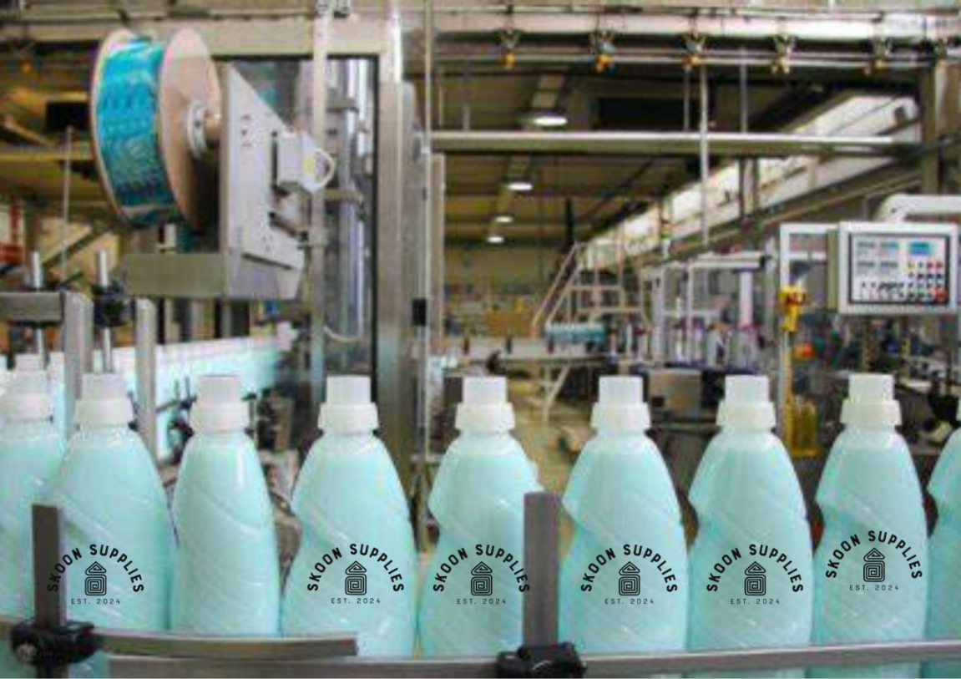

# User Persona

**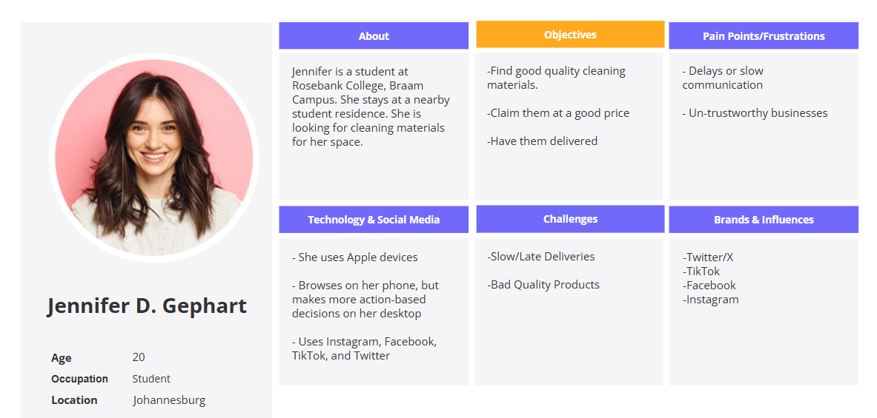**

# Sitemap

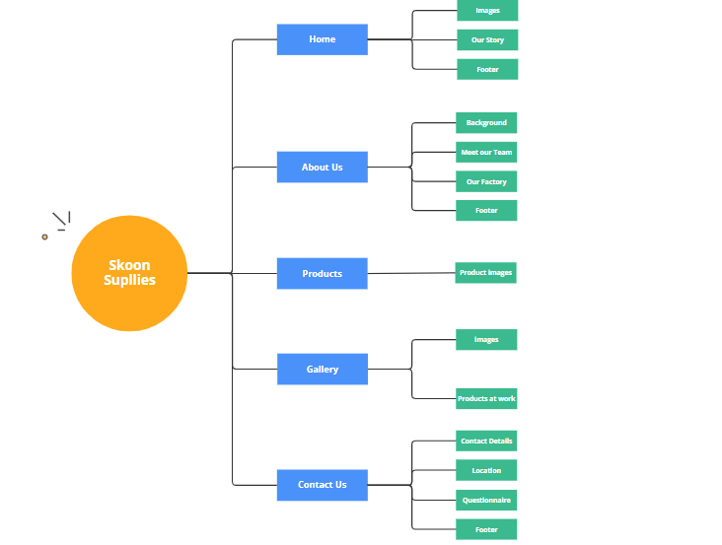

# Reference List

**Across Biotech. (2022)** Phosphoric acid food grade 85% [image]. Available at: [https://cdn-dgcge.nitrocdn.com/JvmFyKzkBmastUBKDcJsrWtvVLMLvwLE/assets/images/optimized/rev-6c2fefb/acrossbiotech.com/wp-content/uploads/2022/06/Phosphoric-acid-food-grade-85-600x568.jpg](https://cdn-dgcge.nitrocdn.com/JvmFyKzkBmastUBKDcJsrWtvVLMLvwLE/assets/images/optimized/rev-6c2fefb/acrossbiotech.com/wp-content/uploads/2022/06/Phosphoric-acid-food-grade-85-600x568.jpg" \t "_new) (Accessed: 20 March 2025).

**Bunnings. (n.d.)** Concrete cleaner product image [image]. Available at: [https://media.bunnings.com.au/api/public/content/0ddb9eb43e1f4b73a1fc19eb43a1cc6c?v=d0e33632&t=w700dpr1](https://media.bunnings.com.au/api/public/content/0ddb9eb43e1f4b73a1fc19eb43a1cc6c?v=d0e33632&t=w700dpr1" \t "_new) (Accessed: 20 March 2025).

**Pinterest. (n.d.)** Chemical barrels image [image]. Available at: [https://i.pinimg.com/originals/78/4d/86/784d86ebc0b04cdc04bc3b1f79b94455.jpg](https://i.pinimg.com/originals/78/4d/86/784d86ebc0b04cdc04bc3b1f79b94455.jpg" \t "_new) (Accessed: 20 March 2025).

**Designboom. (2022)** Francis Kéré Pritzker Prize 2022 image [image]. Available at: [https://www.designboom.com/twitterimages/uploads/2022/03/francis-kere-pritzker-prize-2022-designboom-001.jpg](https://www.designboom.com/twitterimages/uploads/2022/03/francis-kere-pritzker-prize-2022-designboom-001.jpg" \t "_new) (Accessed: 20 March 2025).

**Pick n Pay. (2023)** Household product image [image]. Available at: [https://cdn-prd-02.pnp.co.za/sys-master/images/h11/h94/11128185454622/silo-product-image-v2-16Mar2023-190007-6009218704421-Straight\_on-107537-14115\_400Wx400H](https://cdn-prd-02.pnp.co.za/sys-master/images/h11/h94/11128185454622/silo-product-image-v2-16Mar2023-190007-6009218704421-Straight_on-107537-14115_400Wx400H" \t "_new) (Accessed: 20 March 2025).

**Cleanshop. (2021)** 5L Bleach product image [image]. Available at: [http://site.cleanshop.co.za/wp-content/uploads/2021/12/Bleach-5l-low-R.jpeg](http://site.cleanshop.co.za/wp-content/uploads/2021/12/Bleach-5l-low-R.jpeg" \t "_new) (Accessed: 20 March 2025).

**BigCommerce. (2023)** Cleaning product bottle image [image]. Available at: [https://cdn11.bigcommerce.com/s-64wwb4pbz6/images/stencil/1280x1280/products/51860/19920/19920\_\_41328.1690827919.jpg?c=1](https://cdn11.bigcommerce.com/s-64wwb4pbz6/images/stencil/1280x1280/products/51860/19920/19920__41328.1690827919.jpg?c=1" \t "_new) (Accessed: 20 March 2025).

**Depositphotos. (n.d.)** Production of liquid detergent image [image]. Available at: [https://st.depositphotos.com/1477006/1266/i/380/depositphotos\_12667679-stock-photo-production-of-liquid-detergent.jpg](https://st.depositphotos.com/1477006/1266/i/380/depositphotos_12667679-stock-photo-production-of-liquid-detergent.jpg" \t "_new) (Accessed: 20 March 2025).

**Walmart. (n.d.)** Household cleaner product image [image]. Available at: [https://i5.walmartimages.com/asr/5ae33a1e-d1e7-4e0c-b16a-f0ea7399f25c\_1.b933833bbb074cb898682ffe91558dfd.jpeg?odnHeight=640&odnWidth=640&odnBg=FFFFFF](https://i5.walmartimages.com/asr/5ae33a1e-d1e7-4e0c-b16a-f0ea7399f25c_1.b933833bbb074cb898682ffe91558dfd.jpeg?odnHeight=640&odnWidth=640&odnBg=FFFFFF" \t "_new) (Accessed: 20 March 2025).

**IndiaMART. (n.d.)** Hand wash liquid soap image [image]. Available at: [https://5.imimg.com/data5/SR/TL/MY-4313393/hand-wash-liquid-soaps-500x500.jpg](https://5.imimg.com/data5/SR/TL/MY-4313393/hand-wash-liquid-soaps-500x500.jpg" \t "_new) (Accessed: 20 March 2025).

**iStock. (n.d.)** Unmarked buckets stacked image [image]. Available at: [https://media.istockphoto.com/id/147282078/photo/unmarked-buckets-stacked.jpg?s=1024x1024&w=is&k=20&c=M76NhU2kbH0cFFGj5k0dy7-o8GCOlObOqq0SZX77uVc=](https://media.istockphoto.com/id/147282078/photo/unmarked-buckets-stacked.jpg?s=1024x1024&w=is&k=20&c=M76NhU2kbH0cFFGj5k0dy7-o8GCOlObOqq0SZX77uVc=" \t "_new) (Accessed: 20 March 2025).

**Amazon. (n.d.)** Spray bottle cleaner image [image]. Available at: [https://m.media-amazon.com/images/I/71flVEXYggL.\_AC\_SX679\_.jpg](https://m.media-amazon.com/images/I/71flVEXYggL._AC_SX679_.jpg" \t "_new) (Accessed: 20 March 2025).